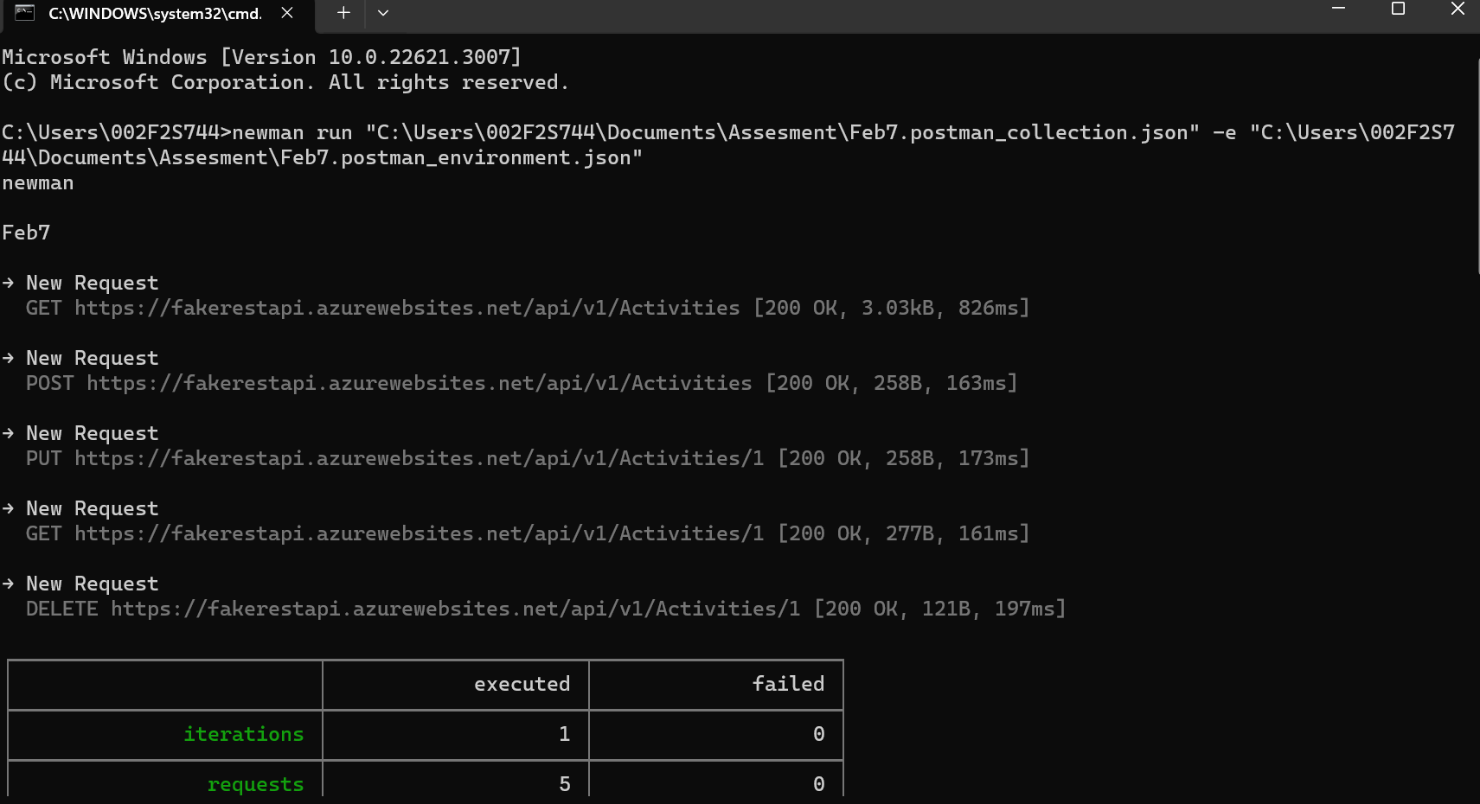

Running Newman complete collection with env variables without data parametrization

Running Newman complete collection with env variables with data parameterization

Post Req in Newman with folder structure using environment variable and with data parametrization.

PUT request using folder structure with data parameterization and env variables.

Running complete collection and generating html report



Running Post request using folder structure and generating report

